REQUEST FOR APPLICATION:  I-Trep One-to-one Consulting Service  2017-2018 | 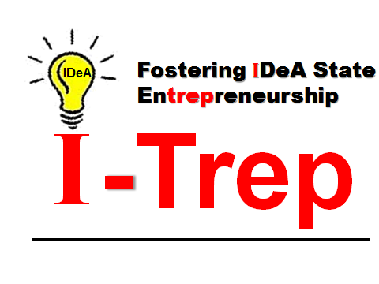
For You: Faculty and Postdoctoral Fellows

Continuing with our mission to promote success in biomedical entrepreneurship, the I-Trep program offers individual one-to-one consulting with experts to assist you with commercializing your innovation.

Assistance is available for, but not limited to, the following areas:

1. SBIR/STTR Phase I submission or resubmission
2. SBIR/STTR Phase II submission or resubmission
3. Setting up and managing your startup
4. Reaching potential investors

Request for this consultant service is available year-round. The request will be submitted to the I-Trep administrative office where it will be discussed by the Steering Committee. If selected, the I-Trep program will put you in contact with an expert to help you with your topic of interest. The I-Trep program will cover the consultation fee.

How to apply:

Submit the following to itrep@uvm.edu:

a) Completed Application Form

b) Current CV

I-Trep Award APPLICATION FORM
One-to-One Mentorship

Qualified applicants include faculty and postdocs

NAME:
POSITION:
INSTITUTION AND DEPARTMENT
(Postdocs) MENTOR’S NAME:
1) A BRIEF BIOGRAPHY (1/4 page max)

2) DESCRIPTION OF YOUR INVENTION (1/4 page max)

3) DESCRIPTION OF WHAT KNOWLEDGE YOU SEEK FROM THIS MENTORSHIP (1/4 page max)

