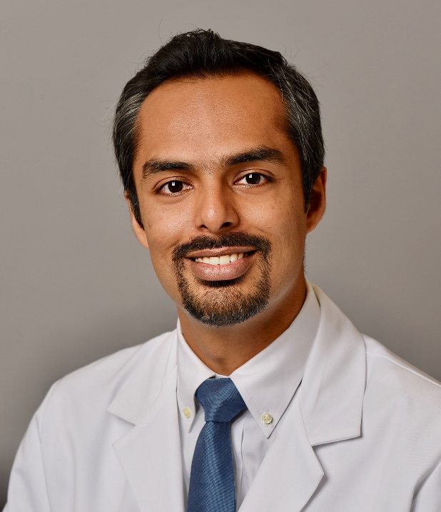

Shahid S. Ahmed, MBBS

Assistant Professor of Medicine, Hematology/Oncology Division
Department of Medicine
Contact Information
E-mail: Shahid.ahmed@uvm.edu
Office Location: Hematology/Oncology Division, 89 Beaumont Avenue, Given Building, Suite E214, Burlington, VT 05405

Education
2005-2010 Aga Khan University, Karachi, Pakistan; MBBS

Postdoctoral Training
2016-2019 Hematology/Oncology fellowship - Chief fellow; Indiana University School of Medicine
2015-2016 Chief residency; Indiana University School of Medicine
2012-2015 Internal medicine residency; Indiana University School of Medicine

Academic Interests
- Understanding and mitigating the adverse effects of Immunotherapies
- Understanding and targeting Cancer Metabolomics
- Clinical trials in Prostate, Bladder, Kidney, Testicular and Skin cancers

Awards
George and Sarah Jane Fisher Young Investigator Award

Publications
Mamdani, H., Ahmed, S. S., Armstrong, S., Mok, T., & Jalal, S. I. (2017). Blood-based tumor biomarkers in lung cancer for detection and treatment. Translational Lung Cancer Research, 6(6), 648-660. doi:10.21037/tlcr.2017.09.03

