Claiming Credit for MOC Activities
- Sign into My Credits
- Click on Dashboard in upper left corner
- Click on Self Assessment in Credits Tile

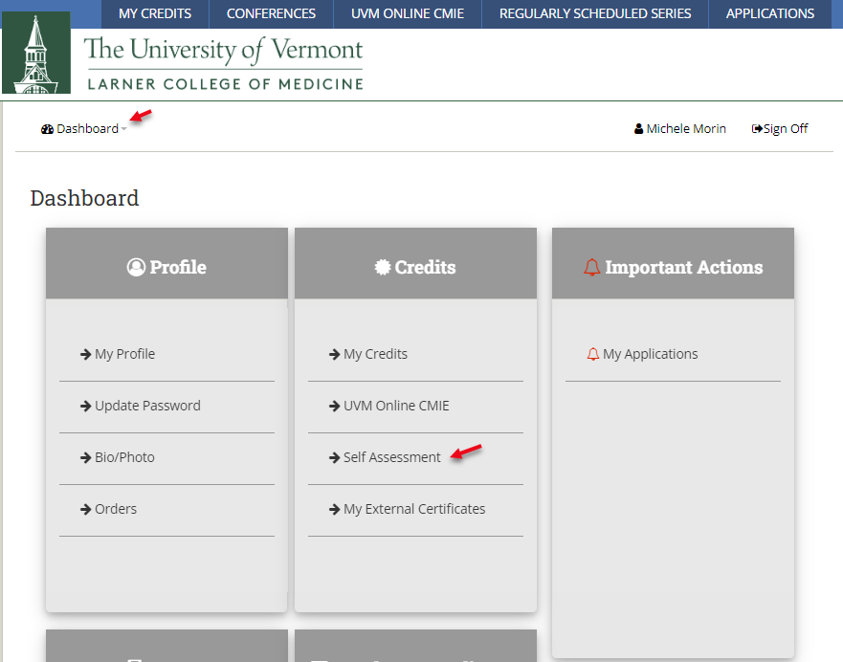

- Click on Search MOC Assessments
- Type title of activity in Text Search field
- Click on Title of activity to complete.
- Click Start MOC

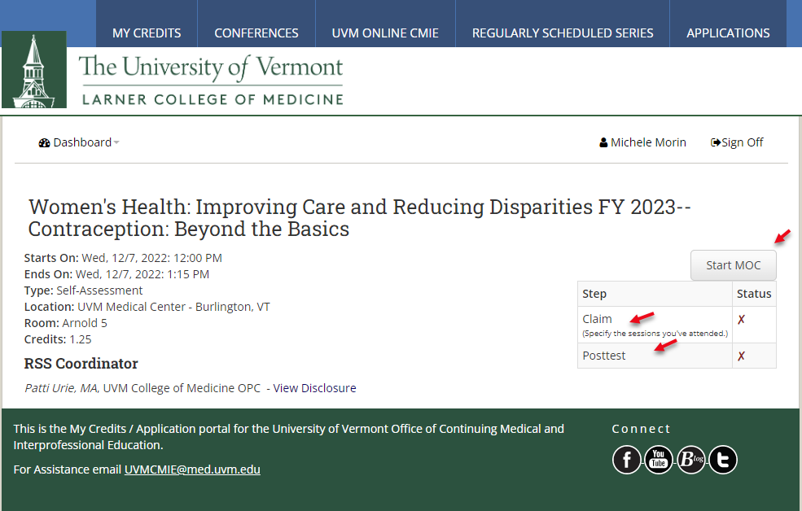

- Click Claim
- Click the I Do Box
- Click Submit
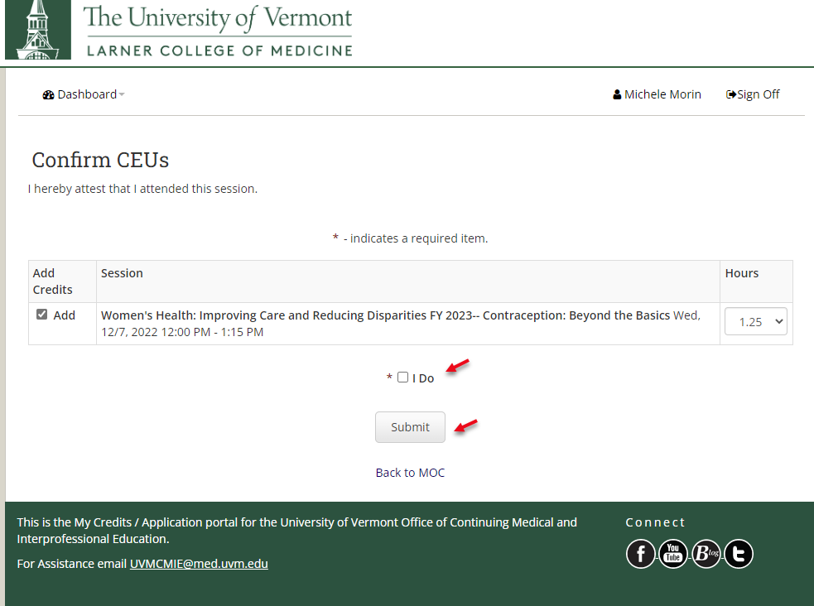
- Click Take Posttest
- Complete the Reflective Statement
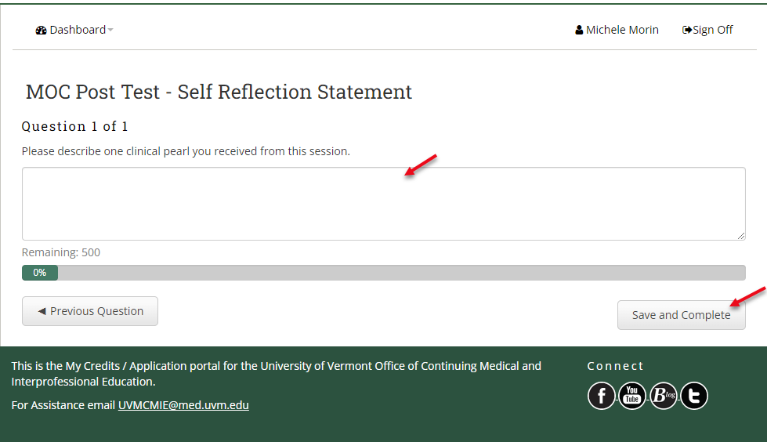
- Click Save and Complete

- To Print Certificate, click dashboard, click My Credits in credits tile.

