The case of disappearing teaspoons: longitudinal cohort study of the displacement of teaspoons in an Australian research institute
Lim et al, BMJ, 2005.

Background: Dr. Lim observed that teaspoons don’t seem to be available when they are needed.
Research Questions: Are teaspoons disappearing from our breakrooms (tearooms)? Do tearoom users take the spoons?
Setting: shared lunch rooms at academic research institution (general lunchroom and more private program-specific lunchroom)
Study Type: prospective longitudinal cohort of teaspoons and survey of tearoom users
Methods:
- 54 standard and 16 high-quality teaspoons were numbered and “enrolled” by being placed in drawers of different tearooms in a research centers
- Both standard and high-quality teaspoons were distributed equally across program-linked and communal tearooms.
- Teaspoons that were already in the drawers not included.
- Monthly teaspoon counts for 5 months, from 2/5/2004-6/18/2004
- Brief survey sent to staff without knowledge of experiment
- Statistics: Kaplan Meier survival curves and summary statistics comparing respondents.
- Co-primary outcomes:
  - Proportion of spoons at the end of the study.
  - Proportion of tearoom users who reported stealing teaspoons.
Impact:
- Identified rates of spoon disappearance would require 252.4 spoons per year to be purchased to maintain a workable spoon population
- Extrapolated to the entire population of Melbourne, an estimated 18 million teaspoons per year go missing. Laid end-to end, these missing spoons could cover over 2700 km (the length of the coastline of Mozambique) and weigh as much as four adult blue whales.
- No institute members ever admitted to removal of spoons, leaving no explanation for their disappearance. Authors discuss potential reasons for spoon disappearance:
  - Tragedy of the commons: In this theoretical perspective, individual cattle herders over-graze common pastureland at the expense of their community, depleting shared grazing land and making it useless. This phenomenon may equally apply to teaspoons.
  - Spoon planet: speculative theory where unattended spoons slip off to live among other spoons on an undiscovered spoon utopia planet.
  - Counterphenomenological resistentialism: The belief that inanimate objects have antipathy towards people and resist our control, in this case, showing ability to migrate and disappear beyond human control.
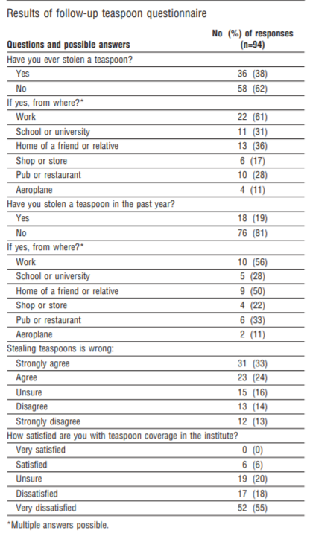
Results
- 56/ 70 (80%) of spoons disappeared
- Teaspoon half-life by setting (figure 1)
  - Communal: 42 days
  - Program-specific: 77 days
  - P < 0.05
- Teaspoon loss by type
  - High quality: 12, expected 12.4
  - Standard: 44, expected 43.6
  - P = 0.88
- Total teaspoon days observed: 5668
- Rate of loss: 0.99 per 100 teaspoon days
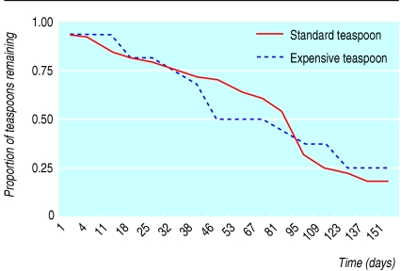
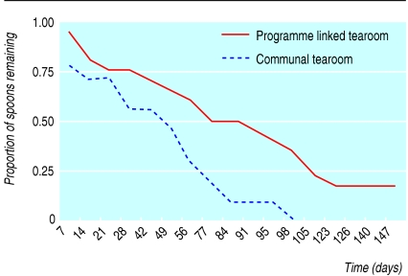
  - 95% confidence interval 0.76-1.28
Figure 2
Figure 1

