STEP 1 - Please CLICK HERE to log into the HighMarks/CME Tracking System or copy & paste the link: https://www.highmarksce.com/uvmmed/
If you are new to our system, PLEASE DO NOT CREATE ANOTHER ACCOUNT – We have added everyone. You just need to complete your profile information. We have added your name and email address already. You will need to click on “Forgot your Password? Get it now!”
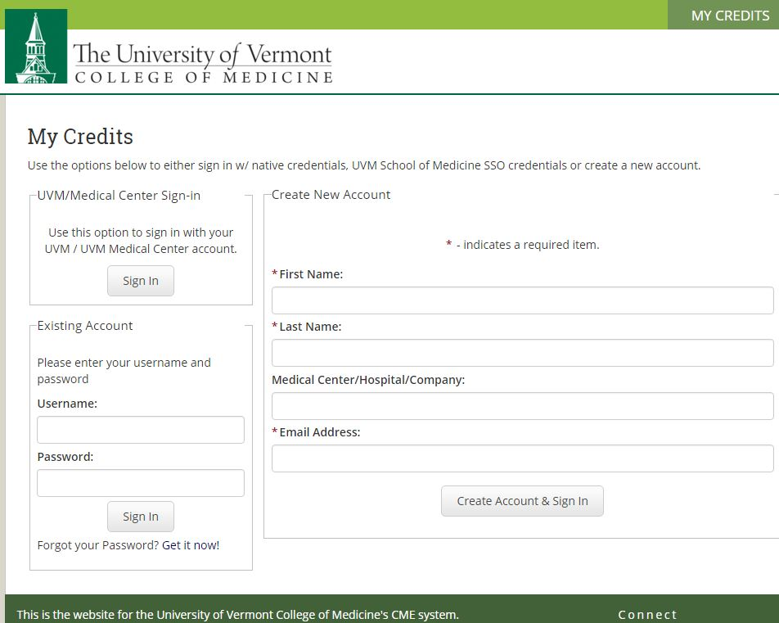
If you are new to our system, we have added your name and email address already. You will click on “Forgot your Password? Get it now!”

STEP 2 – You will then be instructed to enter your name and preferred email (this is the email address I am using to send you this information).
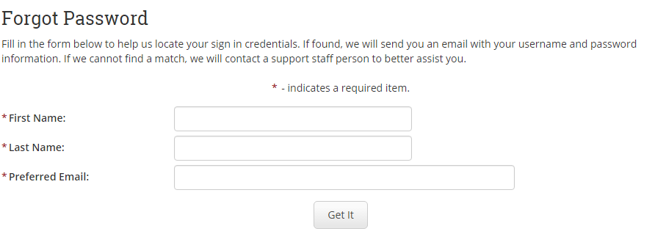
STEP 3 – Enter your profile/contact information
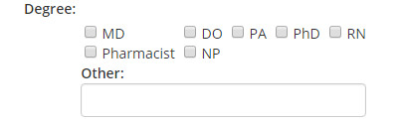
Please make sure to list ALL DEGREES you would like printed on your certificate.
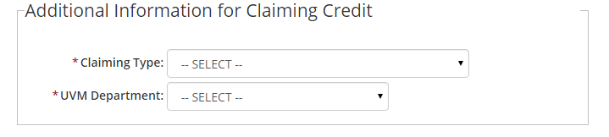
Please select the type of credit you require (Physician, Nurse, Pharmacist etc…).

Step 3 - On your "My Credits" page, you will see "Dashboard" - Please click the down arrow and scroll down to Forms. Click on Financial Disclosure to complete.

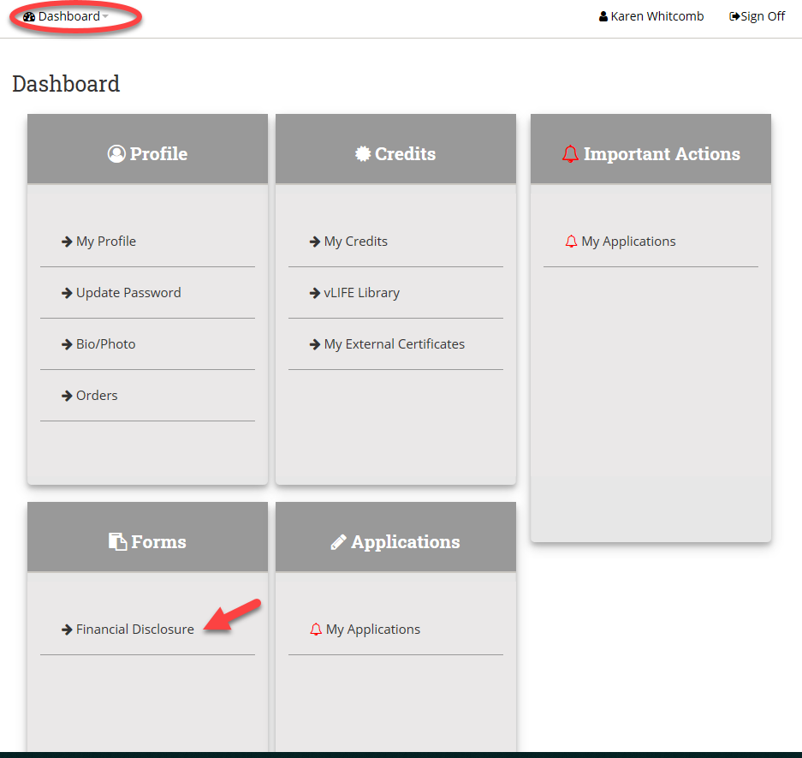
Thank you!

