Directions to Find QR Code

- Log into My Credits.
- Click on Dashboard.
- Click on your activity in the Speaker/Coordinator Center

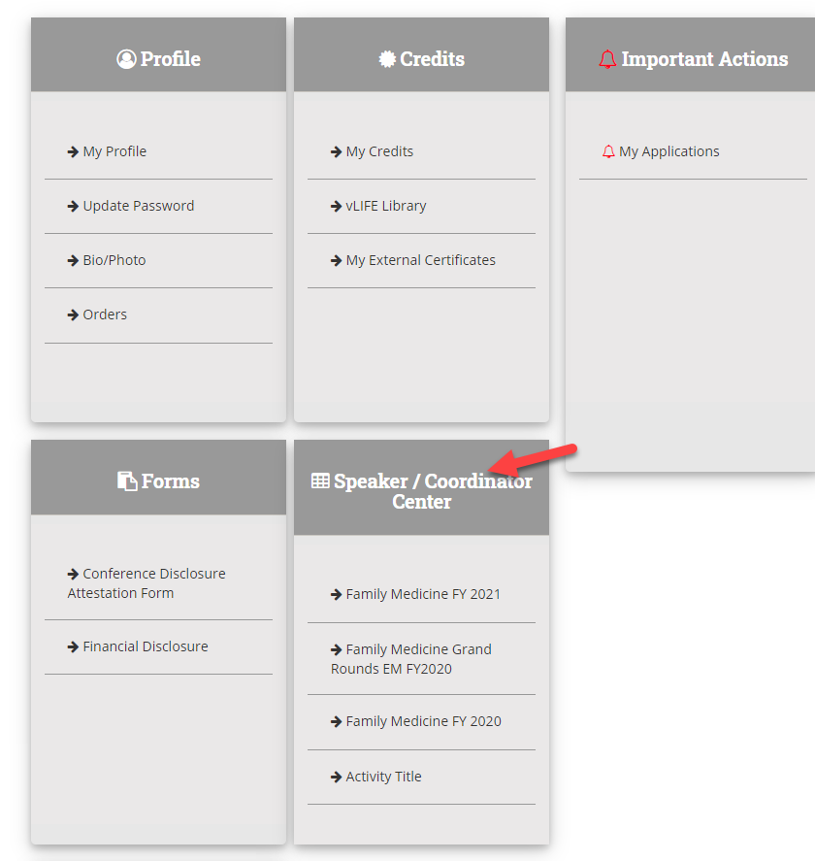

- Click on the activity
- Click on Manage sessions
- Find the session, click on Reporting.
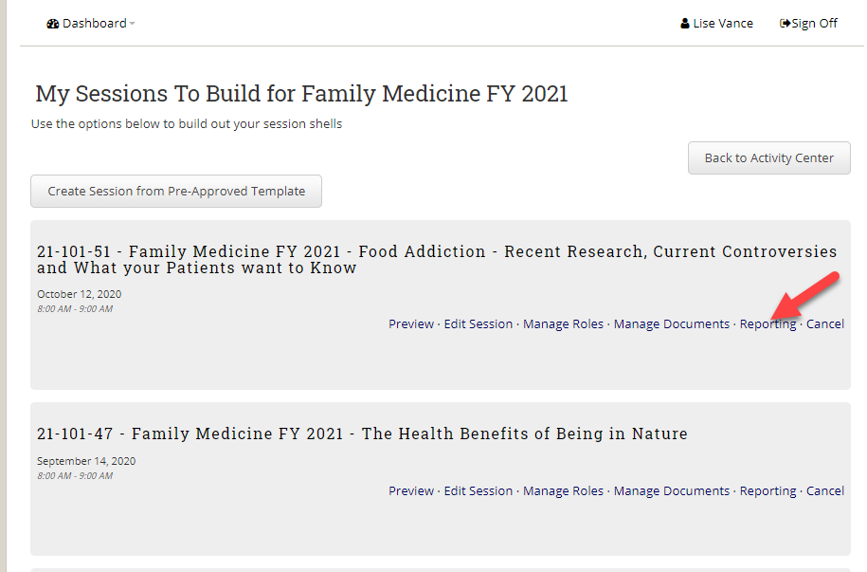
- Click on Get QR Code

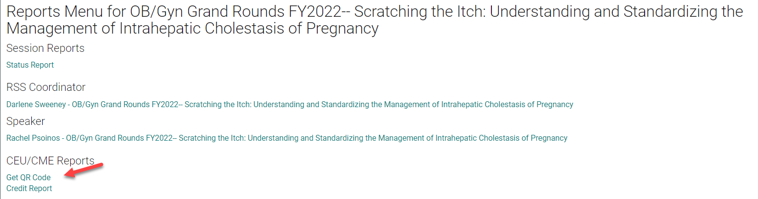

- The system will generate a distributable PDF of the link to claim credit and the QR Code.
