STEP 1 - Please CLICK HERE to log into the HighMarks/CME Tracking System or copy and paste the link: https://www.highmarksce.com/uvmmed/
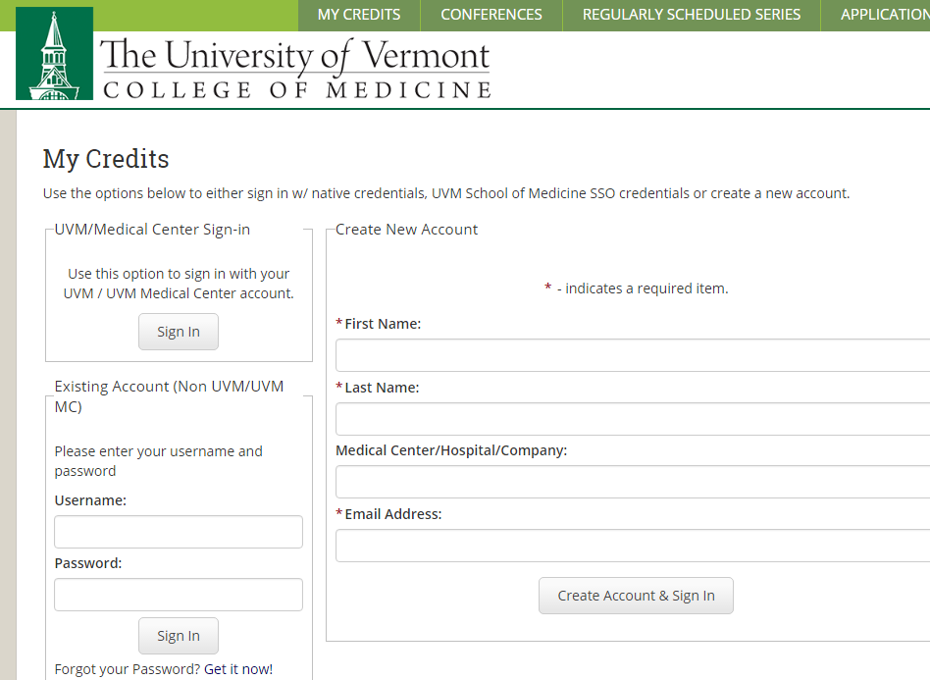
This will bring you to our log in page (if you are UVM/COM or UVM Medical Center, please log in with your M/P number or your UVM/COM login).

If you are new to our system, PLEASE DO NOT CREATE ANOTHER ACCOUNT – We have added everyone. You just need to complete your profile information. We have added your name and email address already. You will need to click on “Forgot your Password? Get it now!”
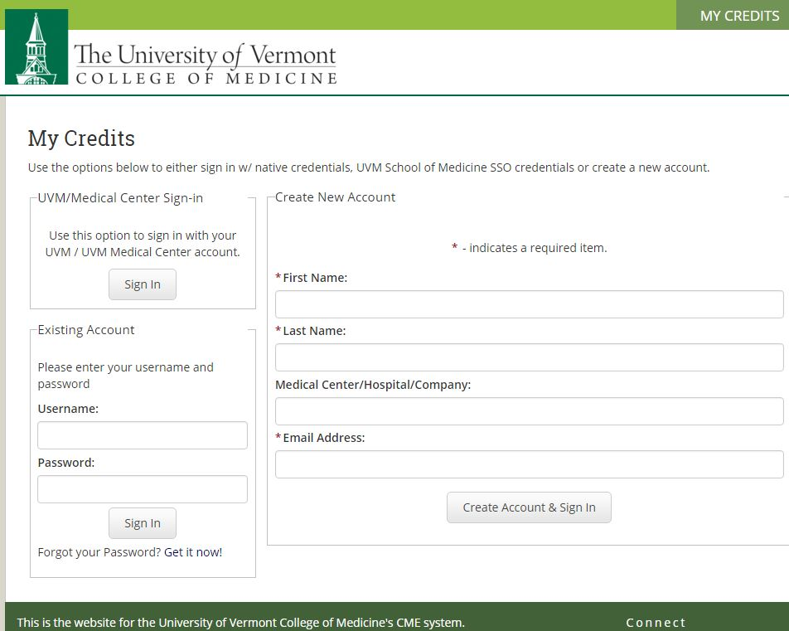
If you are new to our system, we have added your name and email address already. You will click on “Forgot your Password? Get it now!”

STEP 2 – You will then be instructed to enter your name and preferred email (this is the email address I am using to send you this information).
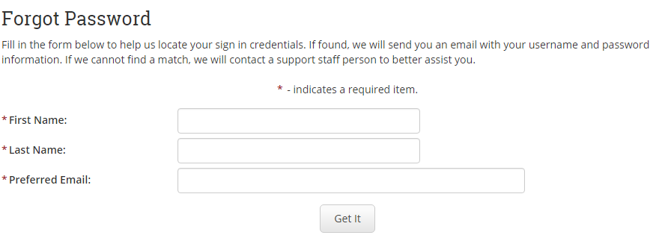
STEP 3 – Enter your profile/contact information
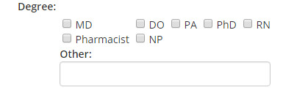
Please make sure to list ALL DEGREES you would like printed on your certificate.
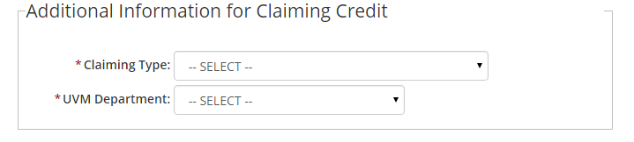
Please select the type of credit you require (Physician, Nurse, Pharmacist etc…).

STEP 4 – Selecting an Activity/Session to Claim Credit
Using the drop down box, select:
Your Activity
You may have to scroll down to find it under 2016.
Then CLICK on List Sessions by Activity
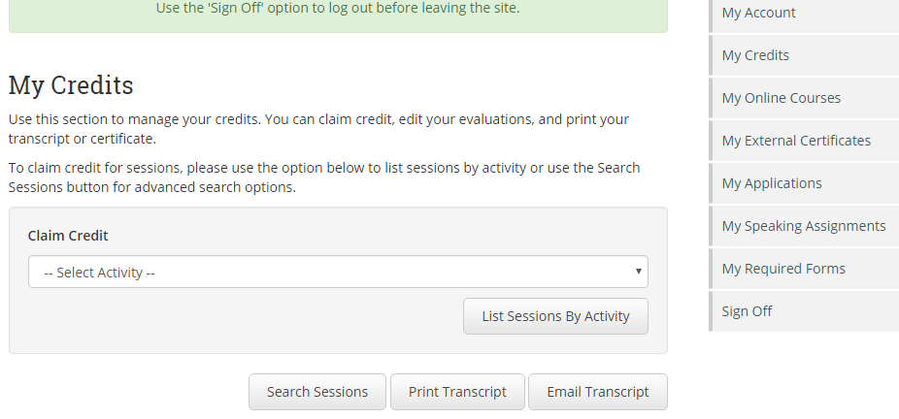

STEP 5 – This will bring you to the agenda with all the sessions listed.
The first Title at the top will be all the conference information and lists.
If you click on the Title of the talk, you will be able to preview the description, objectives, disclosure information.

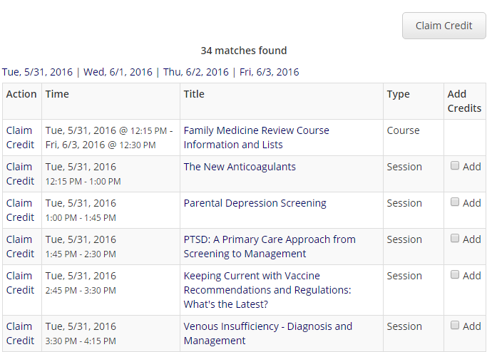
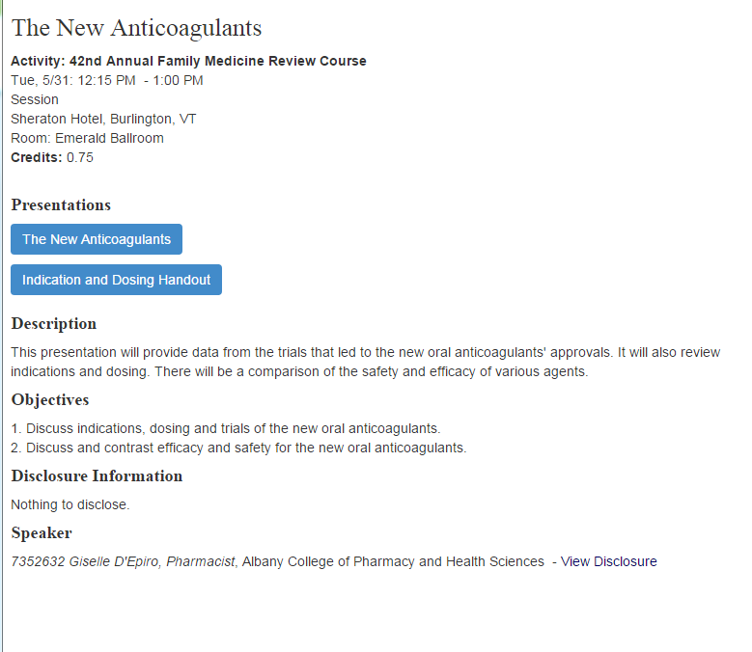
Click on the blue boxes to view/download the presentation(s)
We have not received all presentations for all the talks.

STEP 6 – Collecting your credits.

After attending sessions, you may claim your credits. Simply click on “Add Credits” for the sessions you have attended and scroll down and select “Claim Credit”

Please make sure to claim credits within 30 days of the activity!

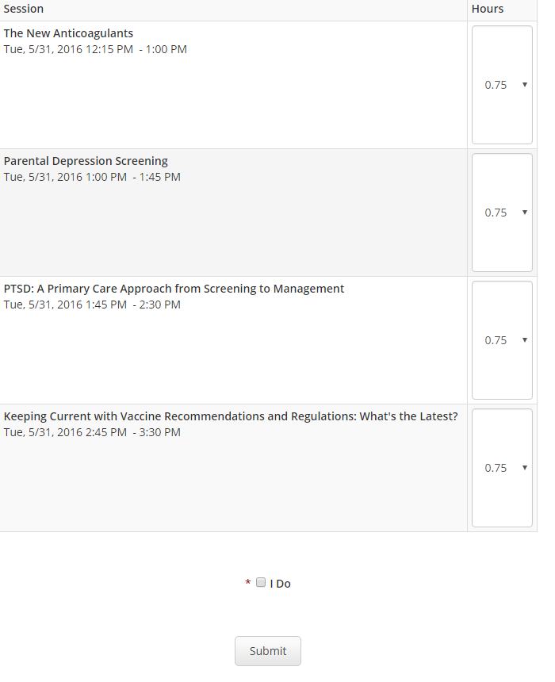
Confirm the hours that you attended for each (the number of credits you actually earned), check the “I Do” and then select “Submit”.

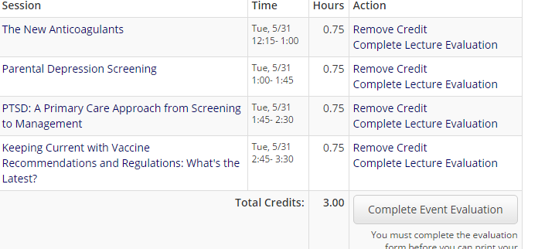
Please be sure to “Complete Lecture Evaluation” for each talk/speaker. They look for and appreciate your feedback!
You will also be required to complete “Event Evaluation.”

STEP 7 – Printing or emailing your certificate:
You can now print or email your certificate. Click what you would like to do.
Please note that you can just leave it in your account and print whenever you are need it!
