Sandra Heibel, CEO, BIOPHARMA GLOBAL, INC

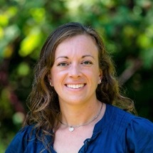

Dr. Sandra Heibel is an independent consultant and serves as the CSO for BioPharma Global. Sandi has worked with Haffner Associates and is the Principal at Heibel Consulting LLC. She has an extensive knowledge of drug development research for rare diseases, regulatory strategy, scientific writing, regulatory submissions, and project management. Sandi also serves as a Project Manager for Scientific Operations at BioPontis Alliance for Rare Diseases, a non-profit corporation dedicated to the development of new therapeutic agents to treat rare diseases. She has a Bachelor’s in Animal Bioscience from Penn State University and completed her Master’s and PhD at the University of Maryland where she studied the molecular biology of rare heritable diseases of metabolism. Through her doctoral experience and as part of a scientist-clinician team, she identified and characterized disease-causing mutations in patients with ultra-rare diseases, assisted with clinical studies, and learned about the need and value of developing drugs for rare diseases.

