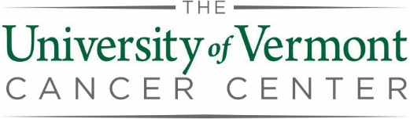

Pilot Project Award Program
Application Checklist
For application submission, please assemble items in the following order into one PDF and send by email to edward.north@uvm.edu with “UVMCC Pilot Project Application” in the subject line.

ITEM | Limit
- Title | As Needed | ☐
- Key Personnel | As Needed | ☐
- Key Words | As Needed | ☐
- Resubmission? | NA | ☐
- Prior Funding | As Needed | ☐
- Overlap | As Needed | ☐
- Regulatory Approvals | NA | ☐
- Shared Resources | NA | ☐
- Lay Summary | 3-4 sentences | ☐
- Abstract | 1 page | ☐
- Leadership Plan | 1 page | ☐
- Specific Aims | 1 page | ☐
- Research Strategy | 5 pages | ☐
- Response to Reviewers (for resubmissions only) | 1 page | ☐
- Literature Citations | As Needed | ☐
- Budget | As Needed | ☐
- Budget Justification | As Needed | ☐
- Departmental Approvals | As Needed | ☐
- Facility Head Approval | As Needed | ☐
- NIH format Biosketches for Key Personnel | 5 pages each | ☐
- Letters of Collaboration or Letters of Support (optional) | As Needed | ☐

Please go to the UVMCC Intramural Funding Web Page
to download forms and related materials.

